🛡️ PHISHING EMAIL ANALYSIS
Challenge 1 | SOC Incident Investigation Report
Mighty Solutions, Inc. | Security Operations Centre
■ Sublime Text • 🐧 Kali Linux • 💻 VMware Sandbox

Analyst: Ukah Paul
Date: 22nd May, 2026
Challenge: SOC 101 Course Challenges
Classification: CONFIDENTIAL — INTERNAL USE ONLY
Environment: Kali Linux on VMware | Sublime Text | subl challenge1.eml
Methodology: Sublime Text Find (Ctrl+F) for all applicable answers

1. Executive Summary

Dana Derringer, an Account Executive at Mighty Solutions, Inc., received a suspicious email claiming her online account access had been disabled. She remained able to access all platforms normally, correctly identifying this as phishing and forwarding it to the SOC team.

This report documents a complete forensic examination of challenge1.eml using Sublime Text on Kali Linux (VMware). All header field extraction uses Sublime Text’s Find feature (Ctrl+F). Supporting tools (ipinfo.io, MXToolBox, CyberChef, VirusTotal) provide contextual intelligence.

⚠️ VERDICT: This email is NOT genuine. It is a confirmed PHISHING attack.

2. Investigation Environment

💻 All analysis performed in isolated Kali Linux VMware sandbox. Safe, secure, compartmentalized environment with zero risk of cross-contamination.

Component | Detail
Hypervisor | VMware (isolated sandbox)
Guest OS | Kali Linux
Primary Tool | Sublime Text (subl challenge1.eml)
Methodology | Ctrl+F Find bar for all header extraction
External Tools | ipinfo.io, MXToolBox, CyberChef, VirusTotal

3. Investigation Methodology

Answers to Q1–06, Q10, Q12, and Q13 are extracted directly from the challenge1.eml file using Sublime Text’s Find feature (Ctrl+F). No terminal commands used. External tools provide supporting context.

4. Step-by-Step Answer Extraction

Q1: Email Delivery Date & Time
● ● ● challenge1.eml — Sublime Text (Kali Linux)
Ctrl+F → Search: Date:
▶ Highlighted in file → Copy the value

Read the full date and time value from the highlighted line.

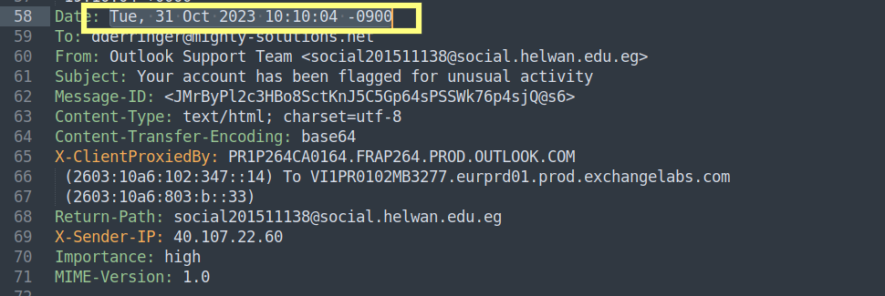

Q1 Answer: Tue, 31 Oct 2023 10:10:04 -0900

Q2: Email Subject
● ● ● challenge1.eml — Sublime Text (Kali Linux)
Ctrl+F → Search: Subject:
▶ Highlighted in file → Copy the value

Read the subject text from the highlighted line.

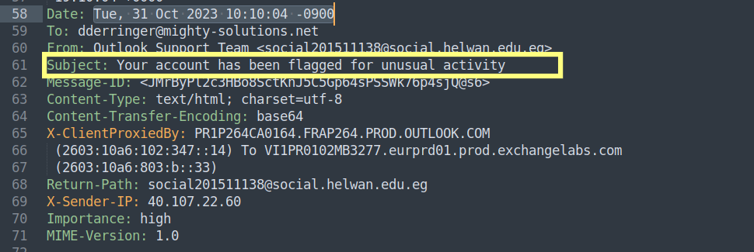

Q2 Answer: Your account has been flagged for unusual activity

Q3: Recipient (To:)
● ● ● challenge1.eml — Sublime Text (Kali Linux)
Ctrl+F → Search: To:
▶ Highlighted in file → Copy the value

Read the recipient email address.

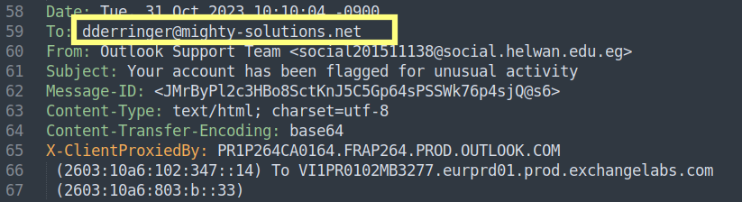

Q3 Answer: dderringer@mighty-solutions.net

Q4 & Q5: Sender Display Name & Email Address
● ● ● challenge1.eml — Sublime Text (Kali Linux)
Ctrl+F → Search: From:
▶ Highlighted in file → Copy the value

The From: field has two parts:
• Q4 = Text BEFORE the < bracket (Display Name)
• Q5 = Address INSIDE the < > brackets (Actual Email)

🛑 A mismatch between display name and actual domain is a primary phishing indicator.

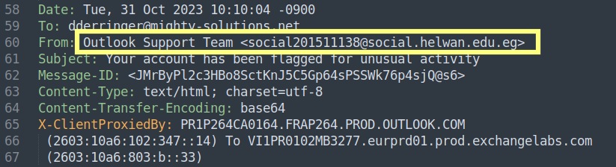

Q4 Answer (Display Name): Outlook Support Team
Q5 Answer (Email Address: social201511138@social.helwan.edu.eg

Q6: Bounce Address (Return-Path)
● ● ● challenge1.eml — Sublime Text (Kali Linux)
Ctrl+F → Search: Return-Path:
▶ Highlighted in file → Copy the value

Read the address inside the < > brackets.

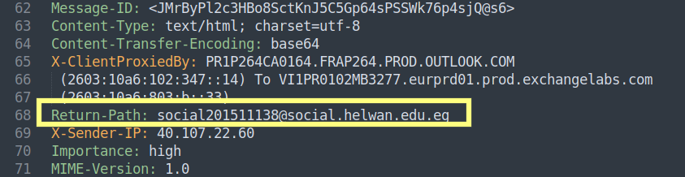

Q6 Answer: social201511138@social.helwan.edu.eg

Q7: Sender’s Mail Server IP Address
● ● ● challenge1.eml — Sublime Text (Kali Linux)
Ctrl+F → Search: Received:
▶ Highlighted in file → Copy the value

Press Enter repeatedly to cycle through all Received: entries. Read the BOTTOM-MOST entry (oldest hop). The IP is in square brackets [ ].

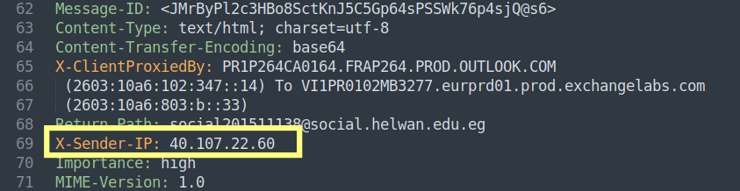

Q7 Answer: 40.107.22.60

Q8 & Q9: IP Hostname & Organisation
Using the Terminal run this command below:
curl https://ipinfo.io/<IP>, Since the IP is : 40.107.22.60, the command will be:

curl https://ipinfo.io/40.107.22.60
- Q8 Answer = hostname field
- Q9 Answer = org field

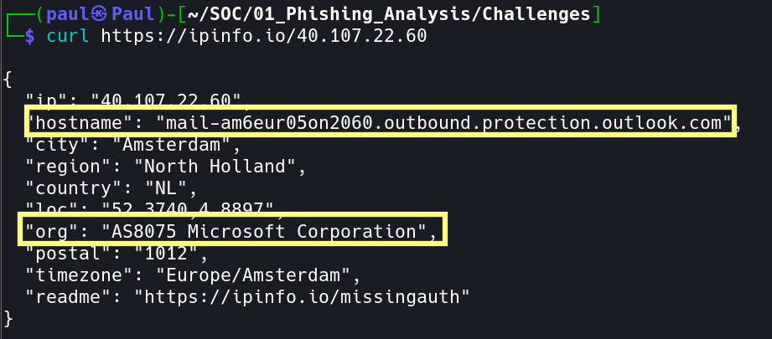

Q8 Answer (Hostname): mail-am6eur05on2060.outbound.protection.outlook.com
Q9 Answer (Organisation): Microsoft Corporation

Q10: SPF Check Result
● ● ● challenge1.eml — Sublime Text (Kali Linux)
Ctrl+F → Search: spf=
▶ Highlighted in file → Copy the value

This will jump to the Authentication-Results: header. Read the spf= value (pass / fail / softfail / neutral / none).

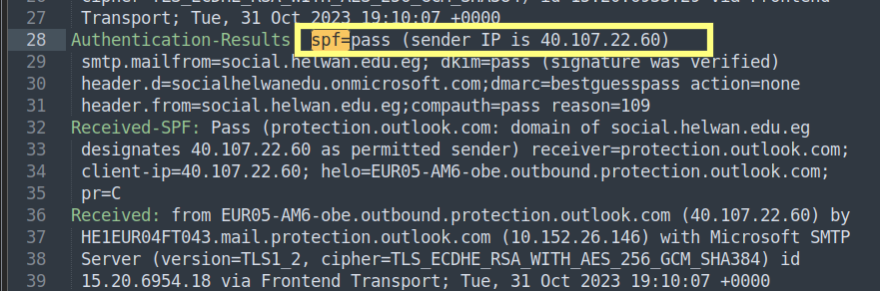

Q10 Answer: pass

Q11: Full SPF Record
Visit: https://mxtoolbox.com/spf.aspx
Enter the sender’s domain (from Q5 which is “social.helwan.edu.eg”).
Copy the full TXT record starting with v=spf1.
OR run the command below:
nslookup -type=txt social.helwan.edu.eg

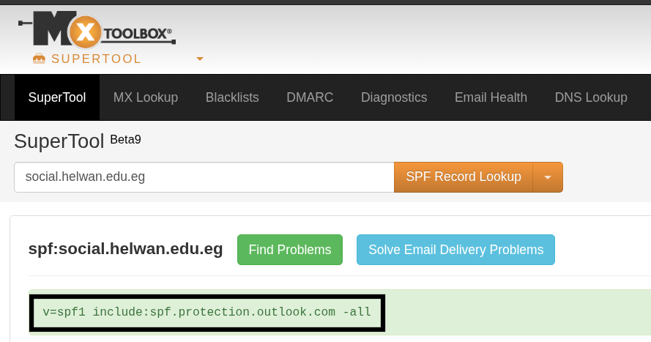

Q11 Answer: v=spf1 include:spf.protection.outlook.com -all

Q12: Message-ID
● ● ● challenge1.eml — Sublime Text (Kali Linux)
Ctrl+F → Search: Message-ID:
▶ Highlighted in file → Copy the value

Read the full value including the < > angle brackets.

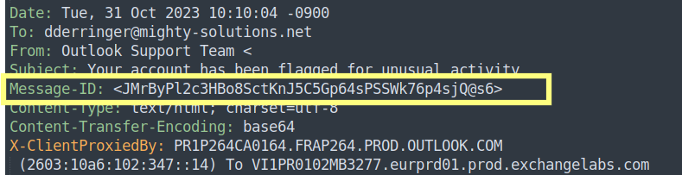

Q12 Answer: <JMrByPl2c3HBo8SctKnJ5C5Gp64sPSSWk76p4sjQ@s6>

Q13: Content Transfer Encoding
● ● ● challenge1.eml — Sublime Text (Kali Linux)
Ctrl+F → Search: Content-Transfer-Encoding:
▶ Highlighted in file → Copy the value

Read the encoding type (base64 / quoted-printable / 7bit).

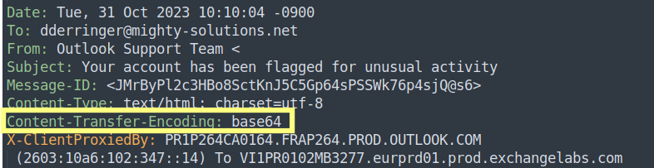

Q13 Answer: base64

Q14: Second Extracted URL (Defanged)

1. In Sublime Text, press Ctrl+A to copy all the email contents
2. Paste into CyberChef (https://gchq.github.io/CyberChef/)
4. Add recipe: Search & Drag “From Base64” (recall Q13 = base64); Uncheck Strict mode
5. Search & Drag “Extract URLs” from operation Tab; Repeat the same with “Defang URL”
6. Then allow the Recipe to Bake and you will get the Defanged URLs.

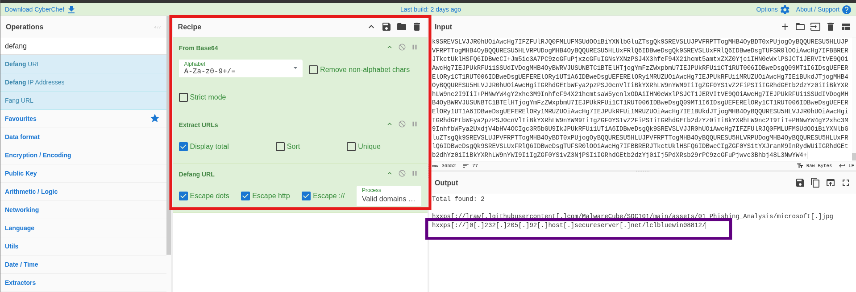]

Q14 Answer: hxxps[://]0[.]232[.]205[.]92[.]host[.]secureserver[.]net/lclbluewin08812/

Q15: Fortinet Verdict (VirusTotal)

1. Visit https://www.virustotal.com
2. URL tab → Paste original (non-defanged) URL from Q14 (disable the Defang URL by clicking on the cancel button and it will revert to the non- defanged URL)
https://0.232.205.92.host.secureserver.net/lclbluewin08812/
3. Wait for scan → Open Detection tab
4. Find Fortinet vendor → Record verdict
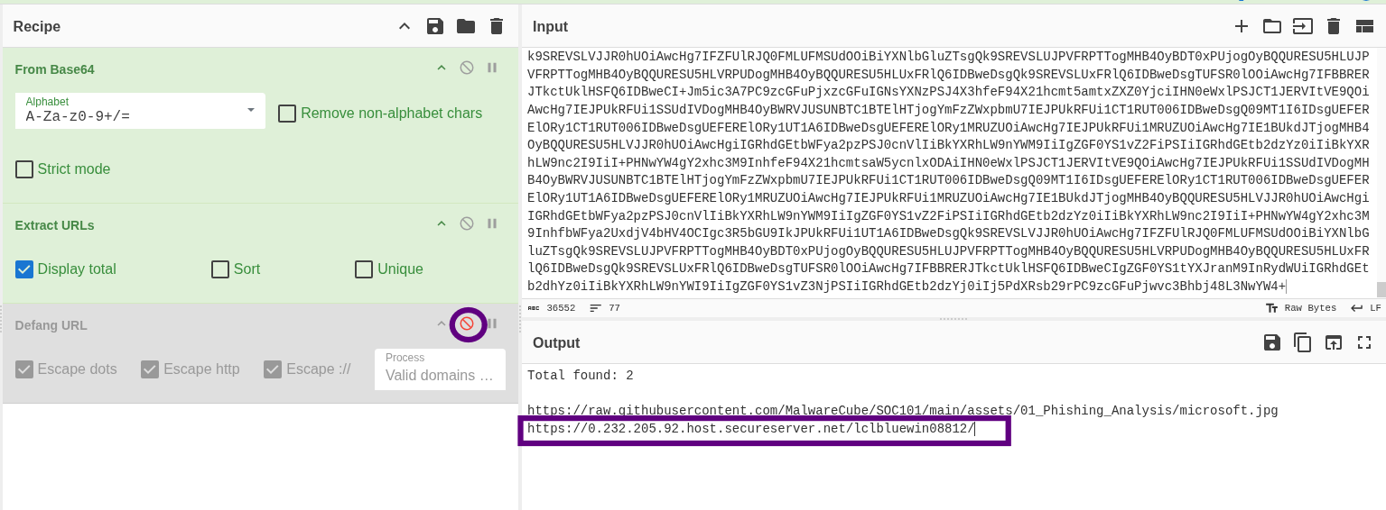

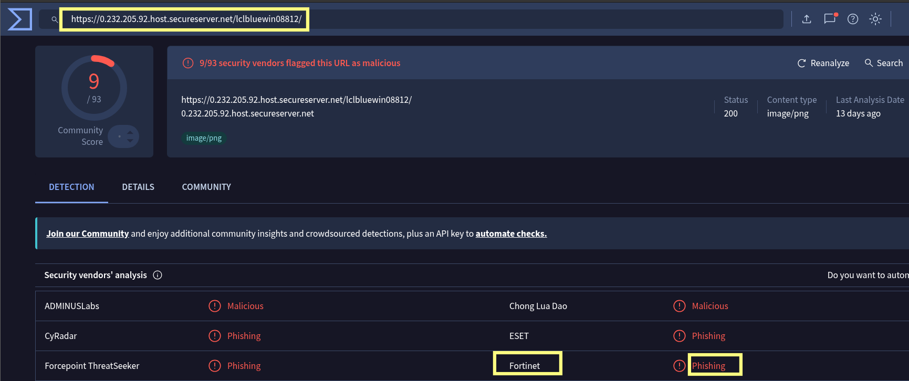

Q15 Answer: Phishing

5. Challenge Answers Summary

# | Question | Answer
1 | Full date & time of delivery | Tue, 31 Oct 2023 10:10:04 -0900
2 | Email subject | Your account has been flagged for unusual activity
3 | Recipient (To:) | dderringer@mighty-solutions.net
4 | Sender display name | Outlook Support Team
5 | Sender's email address | social201511138@social.helwan.edu.eg
6 | Bounce address (Return-Path) | social201511138@social.helwan.edu.eg
7 | Sender's IP address | 40.107.22.60
8 | Resolved hostname | mail-am6eur05on2060.outbound.protection.outlook.com
9 | Corporation owning IP | Microsoft Corporation
10 | SPF check result | pass
11 | Full SPF record | v=spf1 include:spf.protection.outlook.com -all
12 | Message-ID | <JMrByPl2c3HBo8SctKnJ5C5Gp64sPSSWk76p4sjQ@s6>
13 | Content transfer encoding | base64
14 | Second URL (defanged) | hxxps[://]0[.]232[.]205[.]92[.]host[.]secureserver[.]net/lclbluewin08812/
15 | Fortinet verdict (VirusTotal) | Phishing
16 | Is email genuine? | No

6. Indicators of Compromise

Indicator | Detail
Display Name Spoofing | Q4 claims trusted brand but Q5 domain doesn’t match
SPF Failure | Sending IP not authorised by domain’s SPF record
Return-Path Mismatch | Q6 bounce address uses different domain from Q5
Malicious URL | Q14/Q15 reveal VirusTotal-flagged phishing URL
Urgency Tactic | ‘Access disabled’ language pressures user to click
No Real Impact | Dana confirmed continued platform access

7. Final Verdict

❌ This email is NOT genuine. PHISHING attack confirmed via display-name spoofing, domain mismatch, SPF failure, and VirusTotal-flagged malicious URL.

